

**DOCENTE: LIC. LIDIA SANCHEZ**

**SQL SERVER MODULO 1**

**SESION 7 :**

1. **UNIONES EXTERNAS**

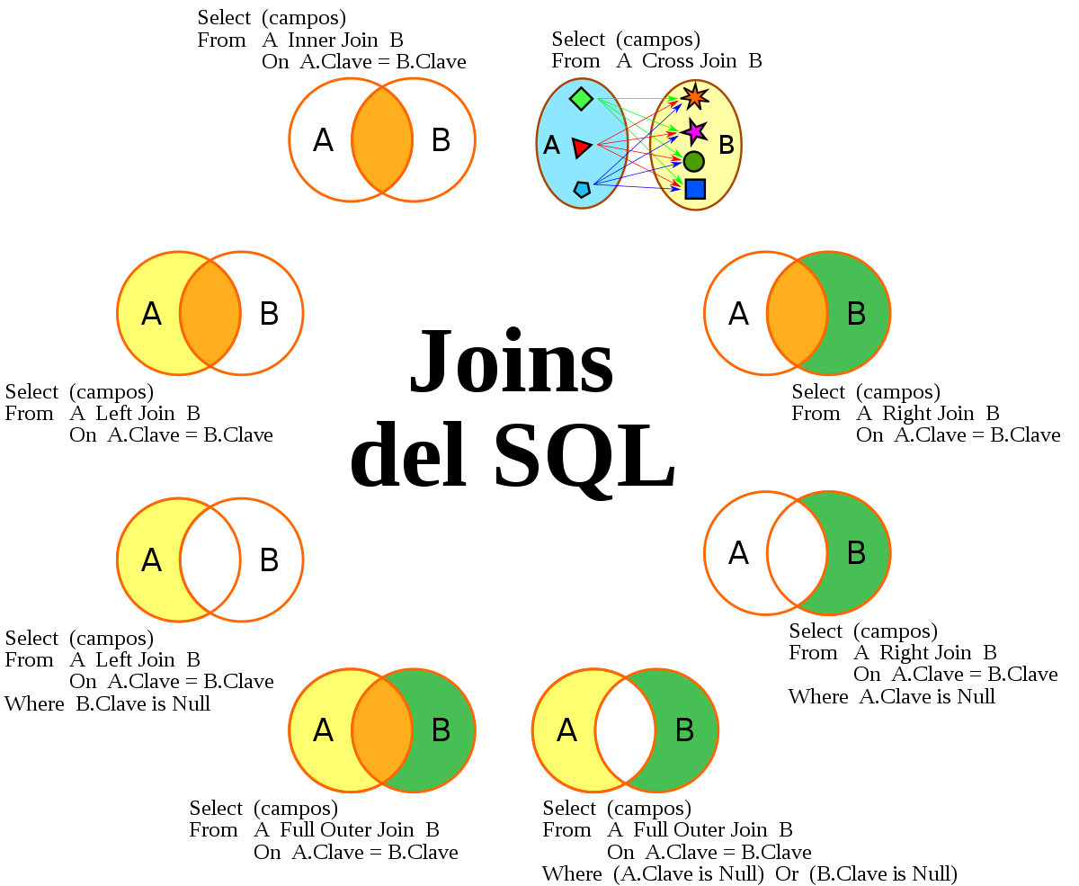

**2. FUNCIONES AGREGADAS**

**https://docs.microsoft.com/en-us/sql/t-sql/queries/select-group-by-transact-sql?view=sql-server-ver16**



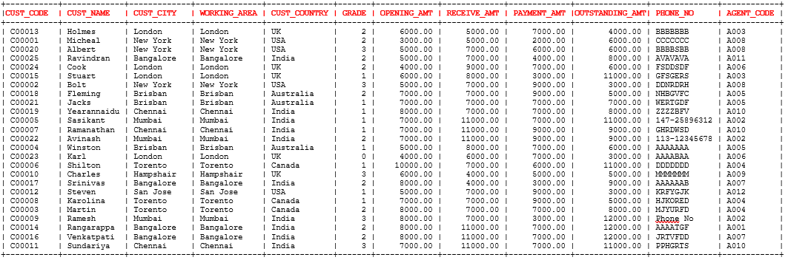

FUENTE : https://www.w3resource.com/sql/aggregate-functions/Max-with-group-by.php

